Họ và tên: Cao Xuân Mai
MSSV: 1150070028
Số Máy 18
Báo Cáo Lab 10–11: Ứng Dụng Truyện Cười
1. Chuẩn bị dự án
• Tạo project Android Studio – Empty Views Activity.
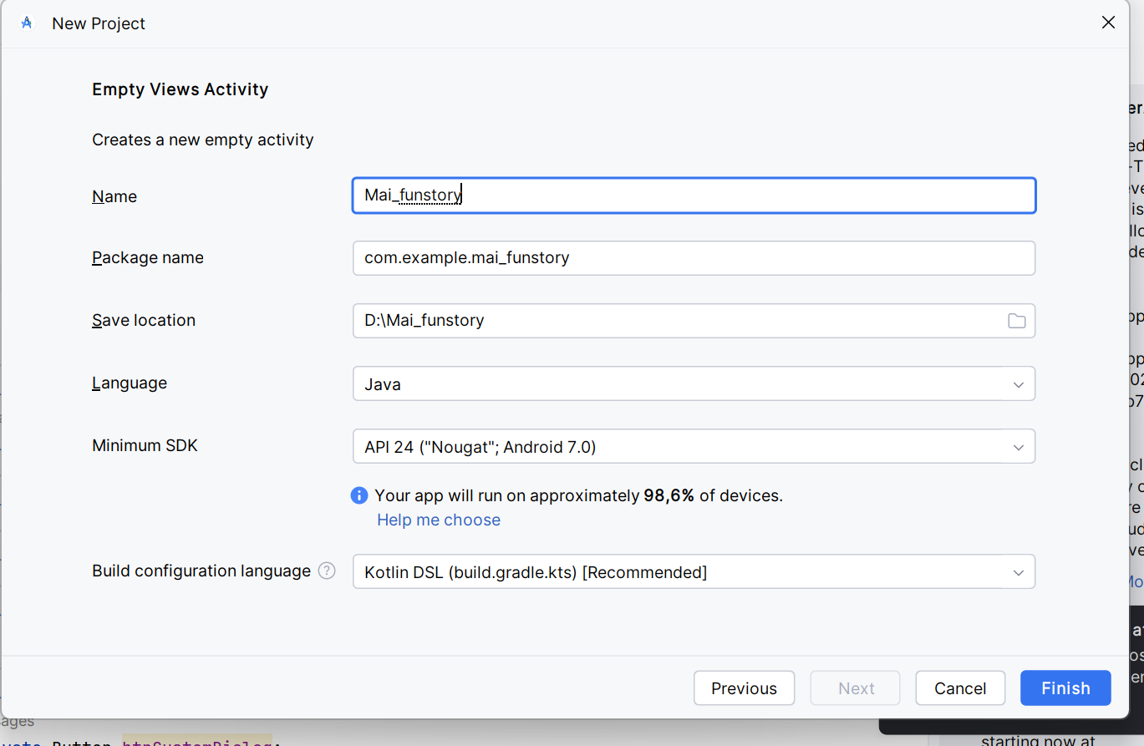
• Tạo thư mục assets/photo và assets/story.
• Tạo file assets/story/trangquynh.txt
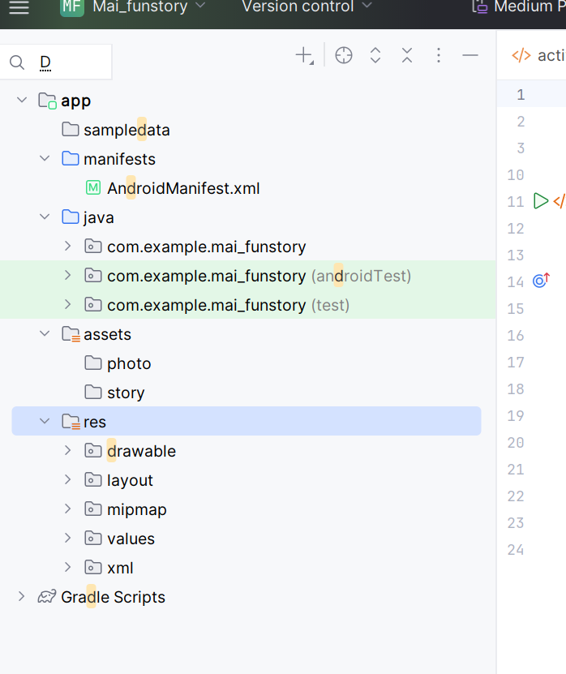
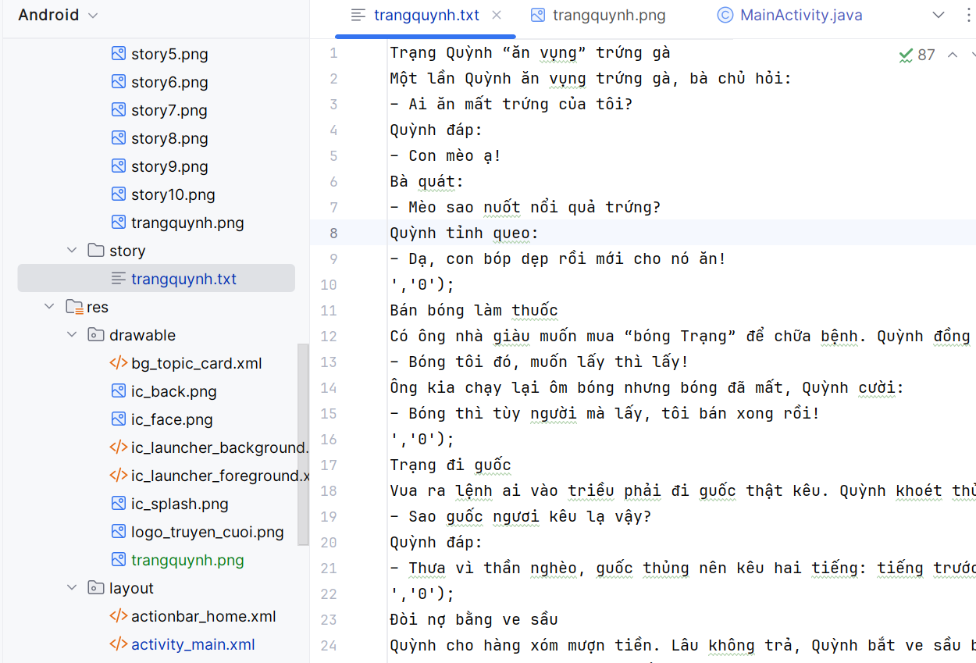
- Chuẩn bị tài nguyên (DRAWABLE – STRING – COLORS – THEMES)
res/values/strings.xml
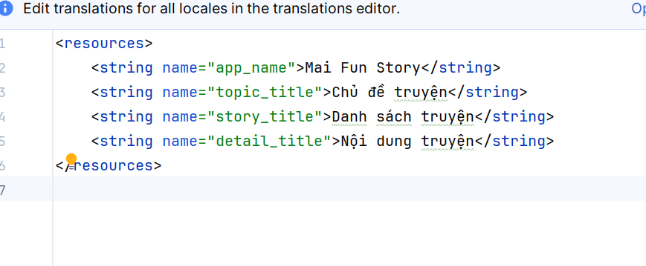
res/values/themes.xml
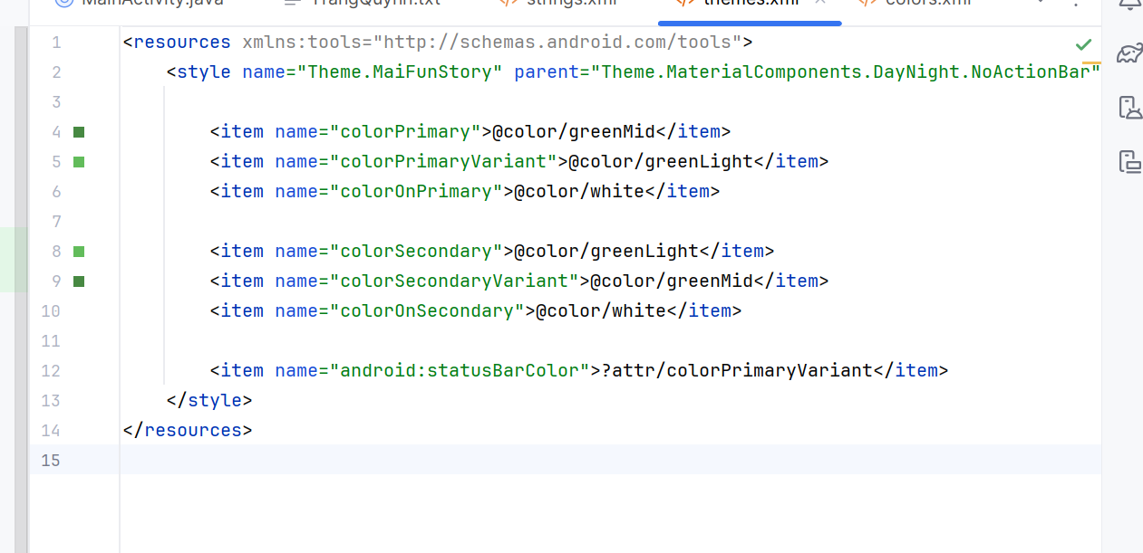
res/values/colors.xml
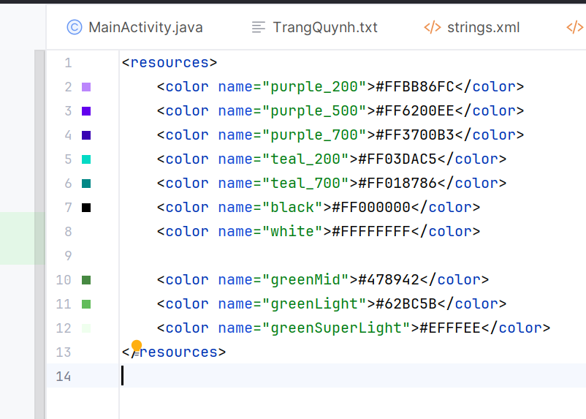
3. Giao diện (XML)
file item_story.xml:

<?xml version="1.0" encoding="utf-8"?>
<LinearLayout ... >
<LinearLayout ... >
<ImageView
android:id="@+id/iv_icon"
android:layout_width="60dp"
android:layout_height="60dp"/>
<TextView
android:id="@+id/tv_story"
android:layout_width="match_parent"
android:layout_height="match_parent"/>
</LinearLayout>
</LinearLayout>
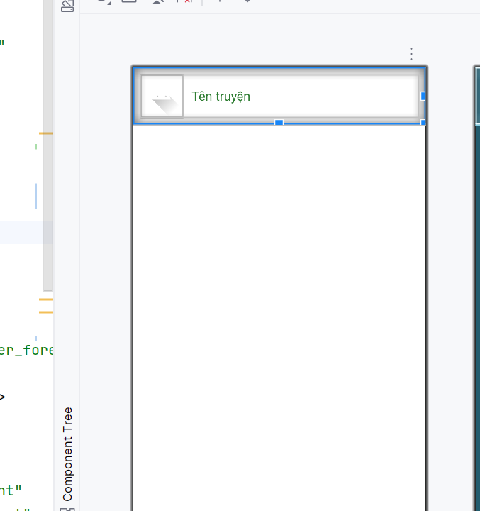4. Adapter hiển thị danh sách truyện
StoryAdapter.java dùng để load icon 1.png, 2.png, ..., 10.png tuỳ theo vị trí:

String fileName = (pos + 1) + ".png";
InputStream is = context.getAssets().open("photo/" + fileName);
Bitmap bitmap = BitmapFactory.decodeStream(is);
h.iv.setImageBitmap(bitmap);
5. File MainActivity.java
Hàm chuyển sang màn đọc truyện M003:
public void gotoM003Screen(ArrayList<StoryEntity> list, StoryEntity s) {
M003DetailStoryFrg frg = new M003DetailStoryFrg();
frg.setData(topicName, list, s);
showFrg(frg);
}
6. M003DetailStoryFrg
Dùng ViewPager để vuốt trái-phải chuyển truyện:
vp.setAdapter(new DetailStoryAdapter(list, context));
vp.setCurrentItem(list.indexOf(current), true);
Sau đây là toàn bộ code hoàn chỉnh:
1. Tạo giao diện XML
1.1 activity_main.xml
Container chứa fragment:
<?xml version="1.0" encoding="utf-8"?><LinearLayout xmlns:android="http://schemas.android.com/apk/res/android"
android:id="@+id/ln_main"
android:layout_width="match_parent"
android:layout_height="match_parent"
android:orientation="vertical" />
1.2 actionbar_home.xml
<?xml version="1.0" encoding="utf-8"?><LinearLayout xmlns:android="http://schemas.android.com/apk/res/android"
android:layout_width="match_parent"
android:layout_height="56dp"
android:orientation="horizontal"
android:background="#4CAF50">

<ImageView
android:id="@+id/iv_back"
android:layout_width="56dp"
android:layout_height="56dp"
android:padding="12dp"
android:src="@drawable/ic_back"
android:visibility="gone"
android:tint="@android:color/white"/>

<TextView
android:id="@+id/tv_name"
android:layout_width="match_parent"
android:layout_height="match_parent"
android:paddingLeft="10dp"
android:gravity="center_vertical"
android:text="Truyện cười"
android:textSize="20sp"
android:textColor="@android:color/white"/>
</LinearLayout>
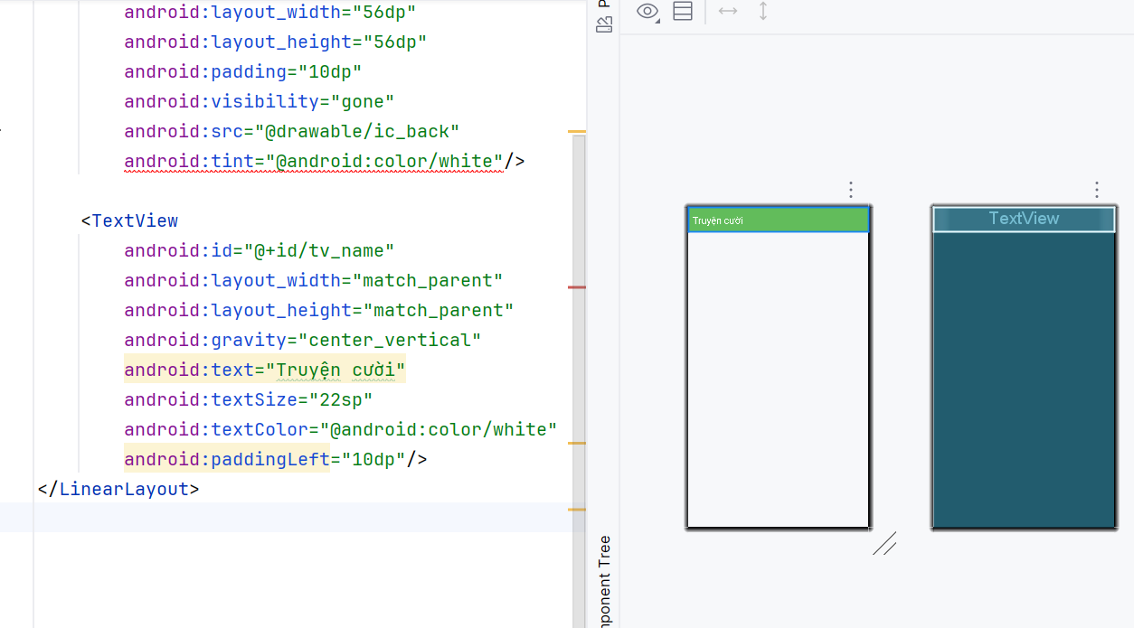
1.3 item_story.xml
<?xml version="1.0" encoding="utf-8"?><LinearLayout xmlns:android="http://schemas.android.com/apk/res/android"
android:layout_width="match_parent"
android:layout_height="wrap_content"
android:background="@android:color/white"
android:orientation="vertical">

<LinearLayout
android:layout_width="match_parent"
android:layout_height="wrap_content"
android:orientation="horizontal"
android:padding="10dp">

<ImageView
android:id="@+id/iv_icon"
android:layout_width="60dp"
android:layout_height="60dp"
android:scaleType="centerCrop"
android:src="@drawable/ic_launcher_foreground"/>

<TextView
android:id="@+id/tv_story"
android:layout_width="match_parent"
android:layout_height="match_parent"
android:paddingLeft="12dp"
android:text="Tên truyện"
android:textSize="18sp"
android:textColor="#2E7D32"
android:gravity="center_vertical"/>

</LinearLayout>

<View
android:layout_width="match_parent"
android:layout_height="1dp"
android:background="#EEEEEE"/>
</LinearLayout>
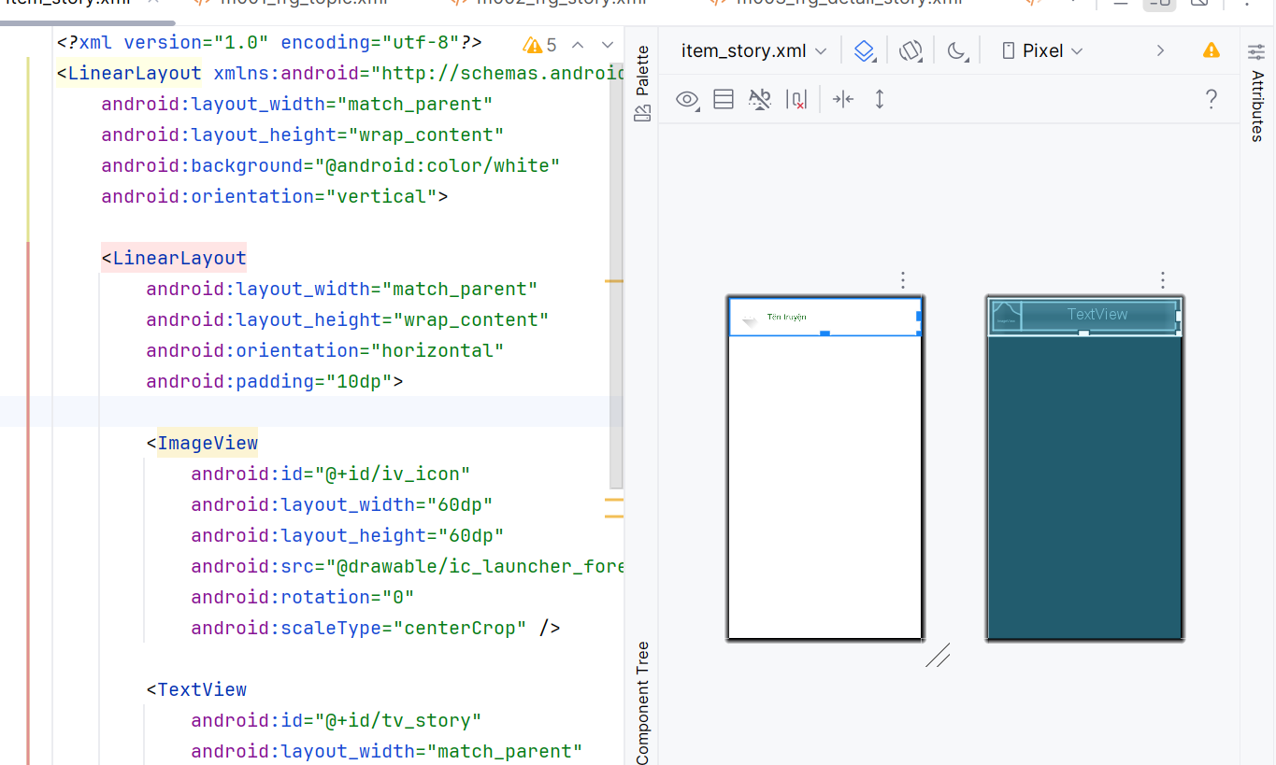
2. Code Java
2.1 MainActivity.java
public class MainActivity extends AppCompatActivity {

private String topicName = "Trạng Quỳnh";

@Override
protected void onCreate(Bundle savedInstanceState) {
super.onCreate(savedInstanceState);
setContentView(R.layout.activity_main);

showFrg(new M000SplashFrg());
}

public void showFrg(Fragment frg) {
getSupportFragmentManager()
.beginTransaction()
.replace(R.id.ln_main, frg)
.commit();
}

public void gotoM001Screen() {
showFrg(new M001TopicFrg());
}

public void gotoM002Screen() {
M002StoryFrg frg = new M002StoryFrg();
frg.setTopicName(topicName);
showFrg(frg);
}

public void backToM001Screen() {
gotoM001Screen();
}
public void gotoM003Screen(ArrayList<StoryEntity> list, StoryEntity s) {
M003DetailStoryFrg frg = new M003DetailStoryFrg();
frg.setData(topicName, list, s);
showFrg(frg);
}
2.2 StoryAdapter.java
public class StoryAdapter extends RecyclerView.Adapter<StoryAdapter.Holder> {

private final ArrayList<StoryEntity> list;
private final Context context;

public StoryAdapter(ArrayList<StoryEntity> list, Context context) {
this.list = list;
this.context = context;
}

@Override
public Holder onCreateViewHolder(ViewGroup parent, int viewType) {
return new Holder(LayoutInflater.from(context)
.inflate(R.layout.item_story, parent, false));
}

@Override
public void onBindViewHolder(Holder h, int pos) {
StoryEntity s = list.get(pos);
h.tv.setText(s.getName());

String fileName = (pos + 1) + ".png";

try {
InputStream is = context.getAssets().open("photo/" + fileName);
Bitmap bitmap = BitmapFactory.decodeStream(is);
h.iv.setImageBitmap(bitmap);
} catch (Exception e) {
e.printStackTrace();
}

h.itemView.setOnClickListener(v ->
((MainActivity) context).gotoM003Screen(list, s)
);
}

@Override
public int getItemCount() {
return list.size();
}

public static class Holder extends RecyclerView.ViewHolder {
TextView tv;
ImageView iv;

public Holder(View itemView) {
super(itemView);
tv = itemView.findViewById(R.id.tv_story);
iv = itemView.findViewById(R.id.iv_icon);
}
}
}
2.3 M002StoryFrg.java – Load truyện từ assets
private ArrayList<StoryEntity> readStory() {
ArrayList<StoryEntity> list = new ArrayList<>();

try {
BufferedReader br = new BufferedReader(
new InputStreamReader(mContext.getAssets()
.open("story/trangquynh.txt"), "UTF-8")
);

String line;
while ((line = br.readLine()) != null) {

String title = line.trim();
if (title.isEmpty()) continue;

StringBuilder content = new StringBuilder();

while ((line = br.readLine()) != null && !line.contains("','0');")) {
content.append(line).append("\n");
}

list.add(new StoryEntity(topicName, title, content.toString()));
}

br.close();

} catch (Exception e) {
e.printStackTrace();
}

return list;
}
2.4 M003DetailStoryFrg.java
package com.example.mai_funstory;
import android.content.Context;
import android.os.Bundle;
import android.view.*;
import android.widget.TextView;
import androidx.fragment.app.Fragment;
import androidx.viewpager.widget.ViewPager;
import com.example.mai_funstory.adapter.DetailStoryAdapter;
import com.example.mai_funstory.model.StoryEntity;
import java.util.ArrayList;
public class M003DetailStoryFrg extends Fragment {
private Context context;
private ArrayList<StoryEntity> list;
private StoryEntity current;
private String topicName;
@Override
public View onCreateView(LayoutInflater inflater, ViewGroup container, Bundle savedInstanceState) {
View v = inflater.inflate(R.layout.m003_frg_detail_story, container, false);
v.findViewById(R.id.iv_back).setVisibility(View.VISIBLE);
v.findViewById(R.id.iv_back).setOnClickListener(v1 ->
((MainActivity)getActivity()).gotoM002Screen()
);
((TextView)v.findViewById(R.id.tv_name)).setText(topicName);
ViewPager vp = v.findViewById(R.id.vp_story);
DetailStoryAdapter adapter = new DetailStoryAdapter(list, context);
vp.setAdapter(adapter);
vp.setCurrentItem(list.indexOf(current), true);
return v;
}
@Override
public void onAttach(Context ctx) {
super.onAttach(ctx);
context = ctx;
}
public void setData(String topic, ArrayList<StoryEntity> list, StoryEntity current) {
this.topicName = topic;
this.list = list;
this.current = current;
}
}
3. Logic hoạt động của ứng dụng
Khi mở app → Splash → chuyển sang M001.
M001 hiển thị chủ đề Trạng Quỳnh.

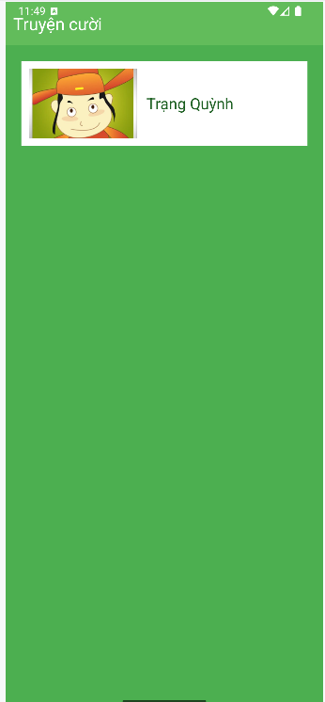
Bấm vào chủ đề → M002 đọc file truyện trong assets.
RecyclerView hiển thị danh sách 10 truyện kèm icon 1–10.
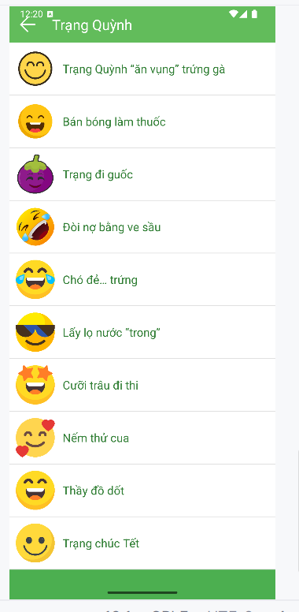
Bấm 1 truyện → M003 hiển thị tiêu đề + nội dung.
Vuốt trái/phải để xem truyện tiếp theo.
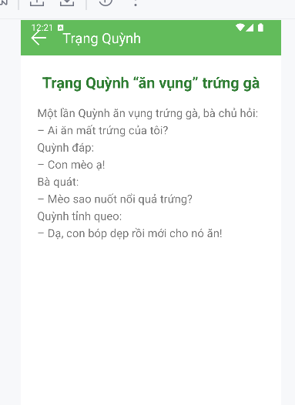
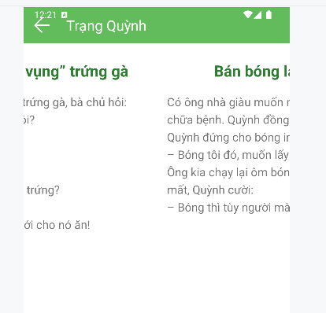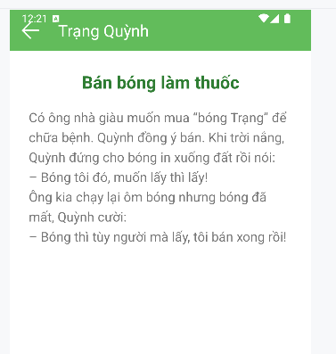
Bài tập làm thêm
Tạo 1 ứng dụng 12 cung hoàng đạo
1. Tạo project mới
Tên: Mai12Cung
Package: com.example.mai12cung
2. Tạo 12 ảnh cung hoàng đạo cho drawable
- res/values/strings.xml
<resources>
<string name="app_name">12 Cung Hoàng Đạo</string>
</resources>
- res/values/colors.xml
<?xml version="1.0" encoding="utf-8"?>
<resources>
<color name="greenMid">#478942</color>
<color name="greenLight">#62BC5B</color>
<color name="greenSuperLight">#EFFFEE</color>
</resources>
5. res/layout/m001_act_menu.xml
<?xml version="1.0" encoding="utf-8"?>
<LinearLayout xmlns:android="http://schemas.android.com/apk/res/android"
xmlns:app="http://schemas.android.com/apk/res-auto"
android:layout_width="match_parent"
android:layout_height="match_parent"
android:orientation="vertical"
android:background="#E3F2FD">
<TextView
android:layout_width="match_parent"
android:layout_height="wrap_content"
android:text="@string/app_name"
android:textSize="28sp"
android:textStyle="bold"
android:gravity="center"
android:padding="16dp"
android:textColor="#1976D2" />
<androidx.constraintlayout.widget.ConstraintLayout
android:layout_width="match_parent"
android:layout_height="0dp"
android:layout_weight="1">
<View
android:id="@+id/center_guide"
android:layout_width="0dp"
android:layout_height="0dp"
app:layout_constraintTop_toTopOf="parent"
app:layout_constraintBottom_toBottomOf="parent"
app:layout_constraintStart_toStartOf="parent"
app:layout_constraintEnd_toEndOf="parent" />
<ImageView android:id="@+id/iv_aries" android:src="@drawable/aries" android:tag="0" app:layout_constraintCircle="@id/center_guide" app:layout_constraintCircleRadius="150dp" app:layout_constraintCircleAngle="0" android:layout_width="70dp" android:layout_height="70dp"/>
<ImageView android:id="@+id/iv_taurus" android:src="@drawable/taurus" android:tag="1" app:layout_constraintCircle="@id/center_guide" app:layout_constraintCircleRadius="150dp" app:layout_constraintCircleAngle="30" android:layout_width="70dp" android:layout_height="70dp"/>
<ImageView android:id="@+id/iv_gemini" android:src="@drawable/gemini" android:tag="2" app:layout_constraintCircle="@id/center_guide" app:layout_constraintCircleRadius="150dp" app:layout_constraintCircleAngle="60" android:layout_width="70dp" android:layout_height="70dp"/>
<ImageView android:id="@+id/iv_cancer" android:src="@drawable/cancer" android:tag="3" app:layout_constraintCircle="@id/center_guide" app:layout_constraintCircleRadius="150dp" app:layout_constraintCircleAngle="90" android:layout_width="70dp" android:layout_height="70dp"/>
<ImageView android:id="@+id/iv_leo" android:src="@drawable/leo" android:tag="4" app:layout_constraintCircle="@id/center_guide" app:layout_constraintCircleRadius="150dp" app:layout_constraintCircleAngle="120" android:layout_width="70dp" android:layout_height="70dp"/>
<ImageView android:id="@+id/iv_virgo" android:src="@drawable/virgo" android:tag="5" app:layout_constraintCircle="@id/center_guide" app:layout_constraintCircleRadius="150dp" app:layout_constraintCircleAngle="150" android:layout_width="70dp" android:layout_height="70dp"/>
<ImageView android:id="@+id/iv_libra" android:src="@drawable/libra" android:tag="6" app:layout_constraintCircle="@id/center_guide" app:layout_constraintCircleRadius="150dp" app:layout_constraintCircleAngle="180" android:layout_width="70dp" android:layout_height="70dp"/>
<ImageView android:id="@+id/iv_scorpio" android:src="@drawable/scorpio" android:tag="7" app:layout_constraintCircle="@id/center_guide" app:layout_constraintCircleRadius="150dp" app:layout_constraintCircleAngle="210" android:layout_width="70dp" android:layout_height="70dp"/>
<ImageView android:id="@+id/iv_sagittarius" android:src="@drawable/sagittarius" android:tag="8" app:layout_constraintCircle="@id/center_guide" app:layout_constraintCircleRadius="150dp" app:layout_constraintCircleAngle="240" android:layout_width="70dp" android:layout_height="70dp"/>
<ImageView android:id="@+id/iv_capricorn" android:src="@drawable/capricorn" android:tag="9" app:layout_constraintCircle="@id/center_guide" app:layout_constraintCircleRadius="150dp" app:layout_constraintCircleAngle="270" android:layout_width="70dp" android:layout_height="70dp"/>
<ImageView android:id="@+id/iv_aquarius" android:src="@drawable/aquarius" android:tag="10" app:layout_constraintCircle="@id/center_guide" app:layout_constraintCircleRadius="150dp" app:layout_constraintCircleAngle="300" android:layout_width="70dp" android:layout_height="70dp"/>
<ImageView android:id="@+id/iv_pisces" android:src="@drawable/pisces" android:tag="11" app:layout_constraintCircle="@id/center_guide" app:layout_constraintCircleRadius="150dp" app:layout_constraintCircleAngle="330" android:layout_width="70dp" android:layout_height="70dp"/>
</androidx.constraintlayout.widget.ConstraintLayout>
<LinearLayout
android:id="@+id/ll_info"
android:layout_width="match_parent"
android:layout_height="wrap_content"
android:orientation="vertical"
android:padding="20dp"
android:background="#FFFFFF"
android:elevation="8dp">
<ImageView
android:id="@+id/iv_selected"
android:layout_width="130dp"
android:layout_height="130dp"
android:layout_gravity="center_horizontal"
android:src="@drawable/aries" />
<TextView
android:id="@+id/tv_name"
android:layout_width="match_parent"
android:layout_height="wrap_content"
android:text="Bạch Dương"
android:textSize="26sp"
android:textStyle="bold"
android:gravity="center"
android:layout_marginTop="12dp"
android:textColor="#1976D2" />
<ScrollView
android:layout_width="match_parent"
android:layout_height="160dp"
android:layout_marginTop="12dp">
<TextView
android:id="@+id/tv_content"
android:layout_width="match_parent"
android:layout_height="wrap_content"
android:text="@string/content_default"
android:textSize="16sp"
android:lineSpacingExtra="6dp" />
</ScrollView>
<Button
android:id="@+id/btn_detail"
android:layout_width="match_parent"
android:layout_height="56dp"
android:text="Xem Thêm"
android:layout_marginTop="16dp"
android:backgroundTint="#1976D2"
android:textColor="#FFFFFF"
android:textStyle="bold" />
</LinearLayout>
</LinearLayout>
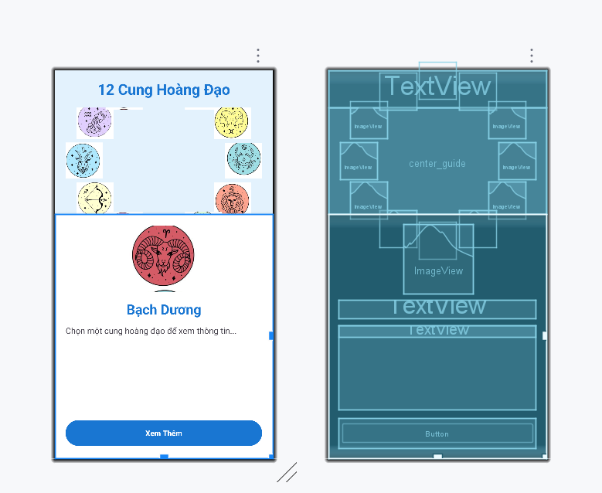
6. res/layoutm002_act_detail.xml
<?xml version="1.0" encoding="utf-8"?>
<LinearLayout xmlns:android="http://schemas.android.com/apk/res/android"
android:layout_width="match_parent"
android:layout_height="match_parent"
android:orientation="vertical"
android:background="#E3F2FD"
android:padding="20dp">
<Button
android:id="@+id/btn_back"
android:layout_width="wrap_content"
android:layout_height="wrap_content"
android:text="QUAY LẠI"
android:backgroundTint="#1976D2"
android:textColor="#FFFFFF" />
<ImageView
android:id="@+id/iv_detail"
android:layout_width="180dp"
android:layout_height="180dp"
android:layout_gravity="center_horizontal"
android:layout_marginTop="20dp"
android:src="@drawable/aries" />
<TextView
android:id="@+id/tv_detail_name"
android:layout_width="match_parent"
android:layout_height="wrap_content"
android:text="Bạch Dương"
android:textSize="28sp"
android:textStyle="bold"
android:gravity="center"
android:layout_marginTop="16dp"
android:textColor="#1976D2" />
<ScrollView
android:layout_width="match_parent"
android:layout_height="match_parent"
android:layout_marginTop="16dp">
<TextView
android:id="@+id/tv_detail_content"
android:layout_width="match_parent"
android:layout_height="wrap_content"
android:textSize="17sp"
android:lineSpacingExtra="8dp" />
</ScrollView>
</LinearLayout>
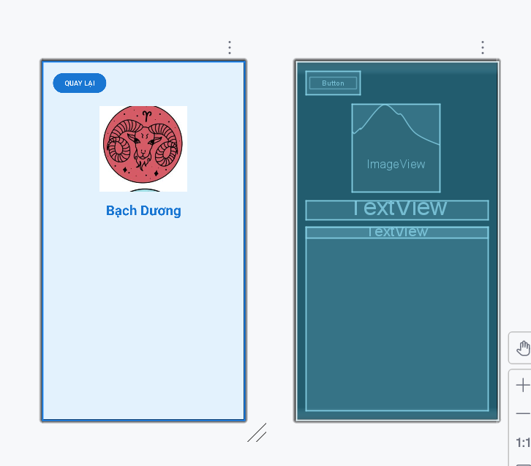
7. M001MenuActivity.java
package com.example.mai12cung;
import android.content.Intent;
import android.os.Bundle;
import android.widget.Button;
import android.widget.ImageView;
import android.widget.TextView;
import androidx.appcompat.app.AppCompatActivity;
public class M001MenuActivity extends AppCompatActivity {
private final int[] zodiacImages = {
R.drawable.aries, R.drawable.taurus, R.drawable.gemini, R.drawable.cancer,
R.drawable.leo, R.drawable.virgo, R.drawable.libra, R.drawable.scorpio,
R.drawable.sagittarius, R.drawable.capricorn, R.drawable.aquarius, R.drawable.pisces
};
private final int[] zodiacIds = {
R.id.iv_aries, R.id.iv_taurus, R.id.iv_gemini, R.id.iv_cancer,
R.id.iv_leo, R.id.iv_virgo, R.id.iv_libra, R.id.iv_scorpio,
R.id.iv_sagittarius, R.id.iv_capricorn, R.id.iv_aquarius, R.id.iv_pisces
};
private final String[] zodiacNames = {
"Bạch Dương", "Kim Ngưu", "Song Tử", "Cự Giải", "Sư Tử", "Xử Nữ",
"Thiên Bình", "Thiên Yết", "Nhân Mã", "Ma Kết", "Bảo Bình", "Song Ngư"
};
private final int[] contentRes = {
R.string.aries_content, R.string.taurus_content, R.string.gemini_content, R.string.cancer_content,
R.string.leo_content, R.string.virgo_content, R.string.libra_content, R.string.scorpio_content,
R.string.sagittarius_content, R.string.capricorn_content, R.string.aquarius_content, R.string.pisces_content
};
private ImageView ivSelected;
private TextView tvName, tvContent;
private Button btnDetail;
private int currentIndex = 0;
@Override
protected void onCreate(Bundle savedInstanceState) {
super.onCreate(savedInstanceState);
setContentView(R.layout.m001_act_menu);
if (getSupportActionBar() != null) getSupportActionBar().hide();
ivSelected = findViewById(R.id.iv_selected);
tvName = findViewById(R.id.tv_name);
tvContent = findViewById(R.id.tv_content);
btnDetail = findViewById(R.id.btn_detail);
for (int i = 0; i < 12; i++) {
final int index = i;
findViewById(zodiacIds[i]).setOnClickListener(v -> showInfo(index));
}
btnDetail.setOnClickListener(v -> {
Intent intent = new Intent(M001MenuActivity.this, M002DetailActivity.class);
intent.putExtra("image", zodiacImages[currentIndex]);
intent.putExtra("name", zodiacNames[currentIndex]);
intent.putExtra("content", getString(contentRes[currentIndex]));
startActivity(intent);
});
showInfo(0);
}
private void showInfo(int index) {
currentIndex = index;
ivSelected.setImageResource(zodiacImages[index]);
tvName.setText(zodiacNames[index]);
tvContent.setText(contentRes[index]);
}
}
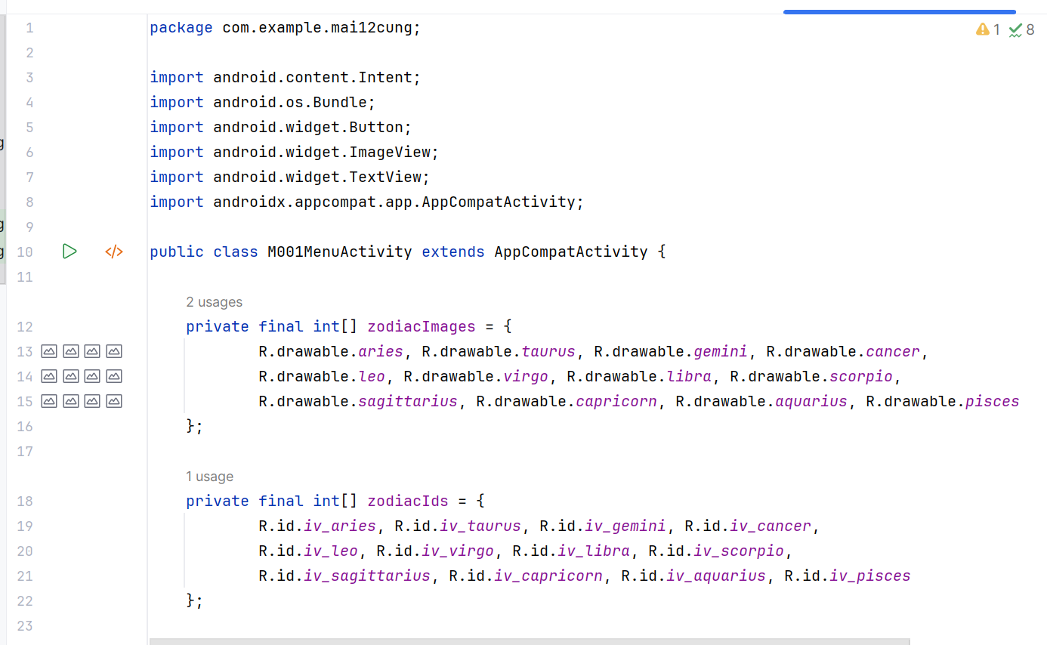
- M002DetailActivity.java
package com.example.mai12cung;
import android.os.Bundle;
import android.widget.Button;
import android.widget.ImageView;
import android.widget.TextView;
import androidx.appcompat.app.AppCompatActivity;
public class M002DetailActivity extends AppCompatActivity {
@Override
protected void onCreate(Bundle savedInstanceState) {
super.onCreate(savedInstanceState);
setContentView(R.layout.m002_act_detail);
if (getSupportActionBar() != null) getSupportActionBar().hide();
ImageView iv = findViewById(R.id.iv_detail);
TextView tvName = findViewById(R.id.tv_detail_name);
TextView tvContent = findViewById(R.id.tv_detail_content);
Button btnBack = findViewById(R.id.btn_back);
iv.setImageResource(getIntent().getIntExtra("image", R.drawable.aries));
tvName.setText(getIntent().getStringExtra("name"));
tvContent.setText(getIntent().getStringExtra("content"));
btnBack.setOnClickListener(v -> finish());
}
}
KẾT QUẢ
Giao diện vòng tròn với mặc định là cung Bạch Dương
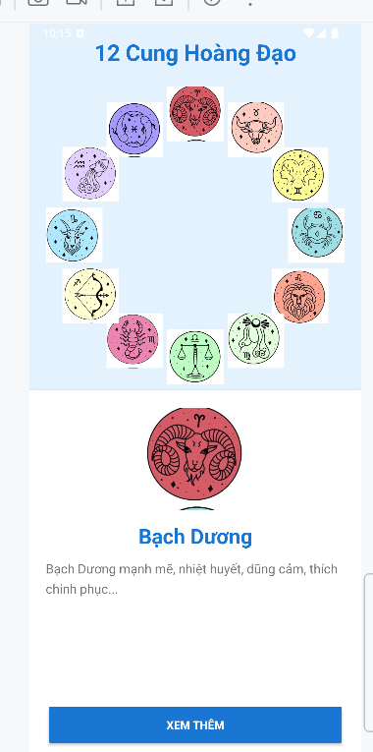
Bấm xem thêm ra giao diện chi tiết cung Bạch dương
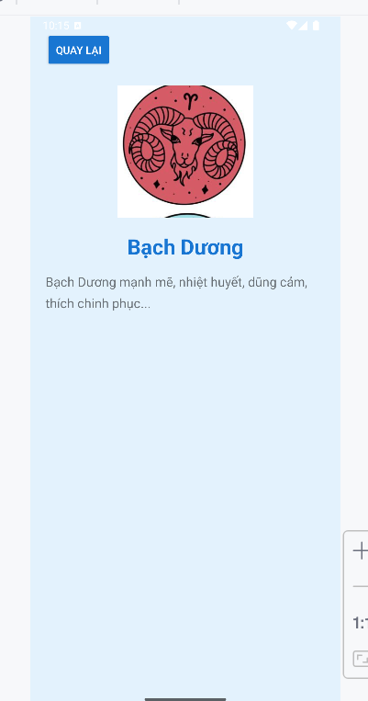
Bấm quay lại ra trang chủ, chọn cung khác vd cung ma kết
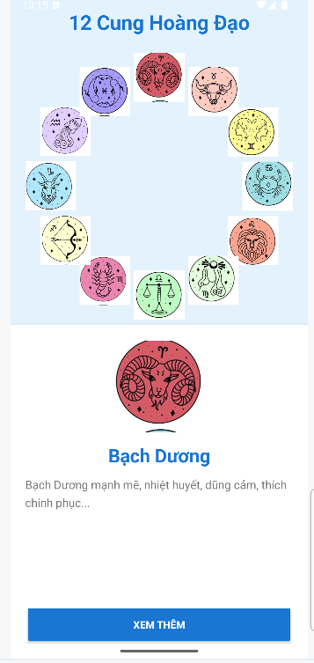
Chi tiết cung ma kết
